Bursting:
Bursting is a process of splitting data into blocks, generating documents for each block, and delivering the documents to one or more destinations. The data for the report is generated by executing a query once and then splitting the data based on a "Key" value. For each block of the data, a separate document is generated and delivered.
Bursting Definition:
A bursting definition is a component of the data model. After you have defined the data sets for the data model, you can set up one or more bursting definitions. When you set up a bursting definition, you define the following:
1) The Split By element is an element from the data that will govern how the data is split.
2) The Deliver By element is the element from the data that will govern how formatting and delivery options are applied.
3) The Delivery Query is a SQL query that you define for BI Publisher to construct the delivery XML data file. The query must return the formatting and delivery details.
In this example it will describe about the Sales Order Acknowledgement Report where we used the bursting concept to send mail to the user based on sales order acknowledged every day. The mail will send to customer after the schedule process executes at particular time.
Here we will see the step by step process bursting has been used to send mail,
Step1:
Create New Bursting
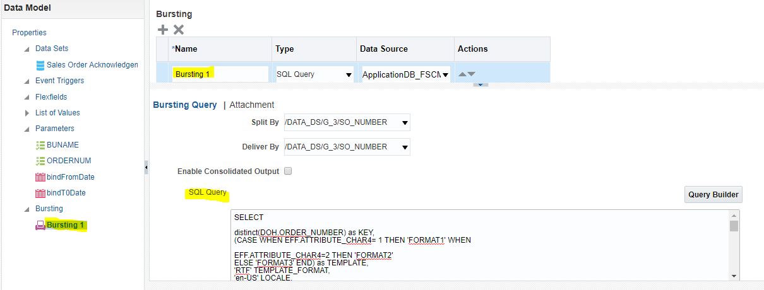

SQL Query :
SELECT
distinct(DOH.ORDER_NUMBER) as KEY,
(CASE WHEN EFF.ATTRIBUTE_CHAR4= 1 THEN 'FORMAT1' WHEN
EFF.ATTRIBUTE_CHAR4=2 THEN 'FORMAT2'
ELSE 'FORMAT3' END) as TEMPLATE,
'RTF' TEMPLATE_FORMAT,
'en-US' LOCALE,
'PDF' OUTPUT_FORMAT,
'EMAIL' DEL_CHANNEL,
REPLACE(DOHEF.ATTRIBUTE_CHAR2,';',',') PARAMETER1,
(CASE WHEN DOHEF.ATTRIBUTE_CHAR2 IS NULL THEN ' ' ELSE 'Global.ERPcloud@vertivco.com' END) AS PARAMETER2,
'donotreply@vertivco.com' PARAMETER3,
'Vertiv Order Acknowledgment (Order Number '|| DOH.ORDER_NUMBER ||';'||'Customer PO Number '
||doh.CUSTOMER_PO_NUMBER||')' PARAMETER4,
'Dear '|| parties.PARTY_NAME || ','||'
Thank you for the recent order you placed with Vertiv. Please review this order acknowledgment thoroughly and notify us immediately of any inaccuracies so that they can be corrected prior to shipment.
We appreciate the opportunity to do business with you!
The Vertiv Team
** This is an automatically generated e-mail which cannot receive replies. **' PARAMETER5,
'true' PARAMETER6

FROM
DOO_HEADERS_EFF_B DOHEF,
DOO_HEADERS_ALL DOH,
HR_ALL_ORGANIZATION_UNITS HOU,
DOO_LINES_ALL DOLL,
DOO_FULFILL_LINES_ALL DOFF,
HZ_PARTIES parties,
Hz_cust_accounts custAccounts,
(SELECT DOHEF.ATTRIBUTE_CHAR4, DOHEF.HEADER_ID FROM
DOO_HEADERS_EFF_B DOHEF, DOO_HEADERS_ALL DOH1 WHERE
DOHEF.HEADER_ID=DOH1.HEADER_ID AND
DOHEF.CONTEXT_CODE='CommonContext')EFF
WHERE
DOHEF.HEADER_ID=DOH.HEADER_ID AND DOHEF.CONTEXT_CODE='CommonContext'
AND TO_CHAR(DOH.LAST_UPDATE_DATE,'DD/MM/YY')=TO_CHAR(SYSDATE,'DD/MM/YY')
AND DOHEF.ATTRIBUTE_CHAR3 = 'Y'
AND EFF.HEADER_ID=DOH.HEADER_ID
and DOH.ORG_ID = HOU.ORGANIZATION_ID
AND DOH.HEADER_ID=DOLL.HEADER_ID
AND DOFF.HEADER_ID=DOH.HEADER_ID
AND DOLL.LINE_ID=DOFF.LINE_ID
AND custAccounts.PARTY_ID =parties.PARTY_ID
AND DOFF.BILL_TO_CUSTOMER_ID = custAccounts.CUST_ACCOUNT_ID
AND doh.CHANGE_VERSION_NUMBER= (SELECT MAX(A.CHANGE_VERSION_NUMBER)
FROM DOO_HEADERS_ALL A WHERE 1=1
AND A.ORDER_NUMBER=doh.ORDER_NUMBER
AND A.ORG_ID =doh.ORG_ID
)
AND custAccounts.ACCOUNT_TERMINATION_DATE >=sysdate
AND (SELECT DOHEF.ATTRIBUTE_CHAR3 FROM DOO_HEADERS_EFF_B DOHEF WHERE DOHEF.HEADER_ID=DOH.HEADER_ID
AND DOHEF.CONTEXT_CODE='CommonContext') = 'Y'
AND DOH.STATUS_CODE <> 'DOO_DRAFT'
AND DOFF.STATUS_CODE <> 'CANCELED'
AND DOH.OPEN_FLAG='Y'
AND NOT EXISTS (SELECT 1 FROM (
--HEADER
SELECT
1 AS LINE_ID,
DOH.HEADER_ID,
DOH.ORDER_NUMBER,
DHC.HOLD_CODE,
DHC.LAST_UPDATE_DATE,
DHO.LAST_UPDATE_DATE AS DT,
DHO.RELEASE_DATE

FROM
DOO_HEADERS_ALL DOH,
DOO_HOLD_INSTANCES DHO,
DOO_HOLD_CODES_B DHC

WHERE
DHO.TRANSACTION_ENTITY_ID1 = DOH.HEADER_ID
AND DHC.HOLD_CODE_ID=DHO.HOLD_CODE_ID
AND DHC.HOLD_CODE IN('ITC_HOLD','DOO_CREDIT_CHECK')
AND DHO.RELEASE_DATE IS NULL
--LINE
UNION ALL
SELECT
DOL.LINE_ID,
DOL.HEADER_ID,
DOL.SOURCE_ORDER_NUMBER,
DHC.HOLD_CODE,
DHC.LAST_UPDATE_DATE,
DHO.LAST_UPDATE_DATE AS DT,
DHO.RELEASE_DATE
FROM
DOO_LINES_ALL DOL,
DOO_HOLD_INSTANCES DHO,
DOO_HOLD_CODES_B DHC
WHERE
DHO.TRANSACTION_ENTITY_ID1 = DOL.LINE_ID
AND DHC.HOLD_CODE_ID=DHO.HOLD_CODE_ID
AND DHC.HOLD_CODE IN('ITC_HOLD','DOO_CREDIT_CHECK')
AND DHO.RELEASE_DATE IS NULL
--FULFILL
UNION ALL
SELECT
DOFL.FULFILL_LINE_ID,
DOFL.HEADER_ID,
DOFL.SOURCE_ORDER_NUMBER,
DHC.HOLD_CODE,
DHC.LAST_UPDATE_DATE,
DHO.LAST_UPDATE_DATE AS DT,
DHO.RELEASE_DATE
FROM
DOO_FULFILL_LINES_ALL DOFL,
DOO_HOLD_INSTANCES DHO,
DOO_HOLD_CODES_B DHC
WHERE
DHO.TRANSACTION_ENTITY_ID1 = DOFL.FULFILL_LINE_ID
AND DHC.HOLD_CODE_ID=DHO.HOLD_CODE_ID
AND DHC.HOLD_CODE IN('ITC_HOLD','DOO_CREDIT_CHECK')
AND DHO.RELEASE_DATE IS NULL
) HLD WHERE HLD.ORDER_NUMBER=DOH.ORDER_NUMBER)
IN the above query,
- KEY is the Delivery key and must match the Deliver By element. The bursting engine uses the key to link delivery criteria to a specific section of the burst data.
- TEMPLATE - is the name of the Layout to apply. Note that the value is the Layout name (for example, 'Customer Invoice'), not the template file name (for example, invoice.rtf).
- LOCALE - is the template locale, for example, 'en-US'.
- OUTPUT_FORMAT - is the output format. For a description of each type, see Setting the Output Types, Oracle Fusion Middleware Report Designer's Guide for Oracle Business Intelligence Publisher. Valid values are:
Supported format in Fusion - HTML, PDF, RTF, EXCEL, PPTX - PowerPoint 2007
- DEL_CHANNEL - is the delivery method. Valid values are:
Supported method: EMAIL, FAX, FILE, PRINT
- OUTPUT_NAME - is the name that will be assigned to the output file in the report job history.
Below Parameter's are used for the above bursting query.
- PARAMETER1: Email address
- PARAMETER2: cc
- PARAMETER3: From
- PARAMETER4: Subject
- PARAMETER5: Message body
- PARAMETER6: Attachment value ('true' or 'false'). If your output format is PDF, you must set this parameter to "true" to attach the PDF to the e-mail.

To Check the Sale order is acknowledged we use the condition in above bursting query,
AND (SELECT DOHEF.ATTRIBUTE_CHAR3 FROM DOO_HEADERS_EFF_B DOHEF WHERE DOHEF.HEADER_ID=DOH.HEADER_ID AND DOHEF.CONTEXT_CODE='CommonContext') = 'Y'
The Acknowledgement flag should be Y

Step 2:
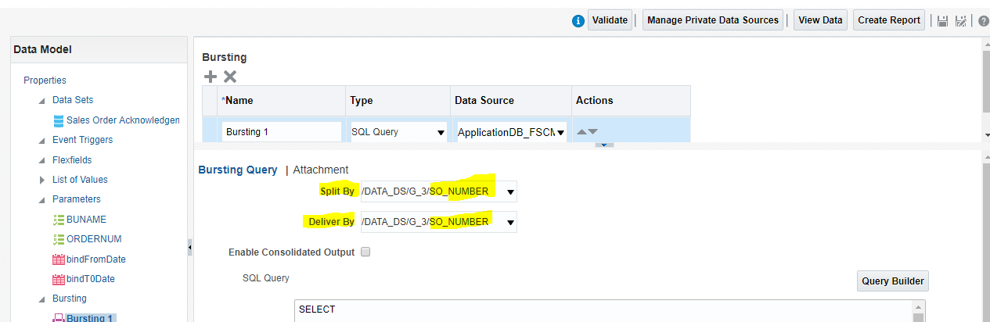

In above attached we specified split by and deliver by options
1) Split By - Select the element from the data set by which to split the data. For above example given the element as SO_NUMBER (Sales Order Number Column).
2) Deliver By - Select the element from the data set by which to format and deliver the data. For above example given the element as SO_NUMBER (Sales Order Number Column).

Once the bursting statement defined, go to Report properties to enable bursting.
Edit Report → Properties → Check Enable Bursting (Note: Make sure the created bursting is available)

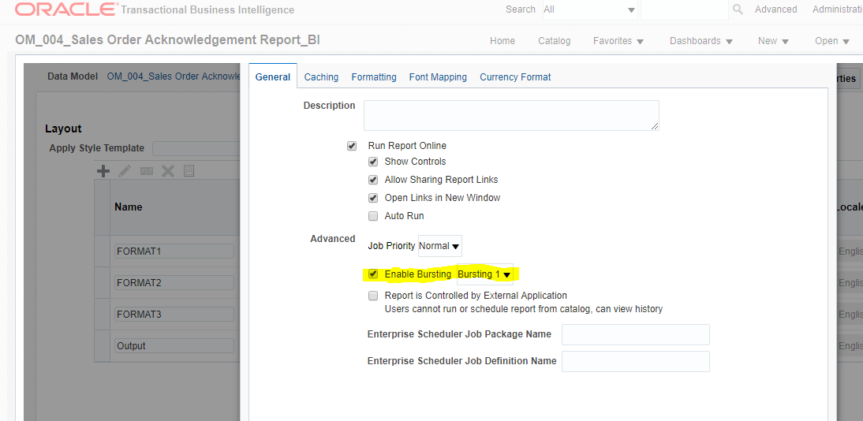

Step 3:
Schedule report using report job.
Select → Schedule
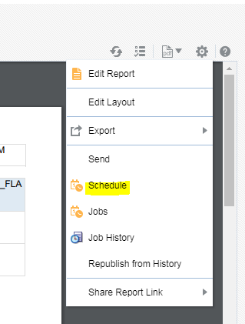
Make sure the bursting definition enabled in output tab like below screenshot
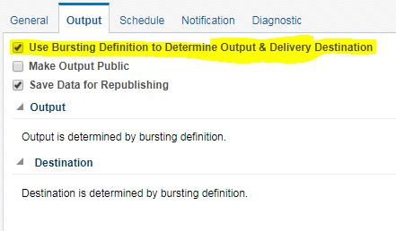
Click → Submit
Step 4:
Mail
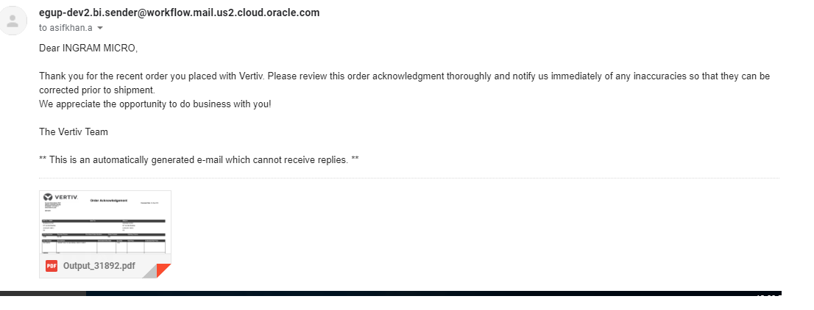
Finally the Ouput of the Report has been Mailed for sales order acknowledged on that day.

